High precision chronometer

Specifications

from µsec up to 99u 59min 59sec 999msec 999µsec.

GPS module time base
STM32F411CEU used for timer and 8 digit LED display
ESP32 for LCD display, data keeping an web page with all the registered times.
maximum 500 time registrations
registered times are stored SPIFFS flash memory of ESP32
reset registered only possible at start-up
actual time visible on 8 digit led display
last registered time visible on LCD display
all registered times visible on web page

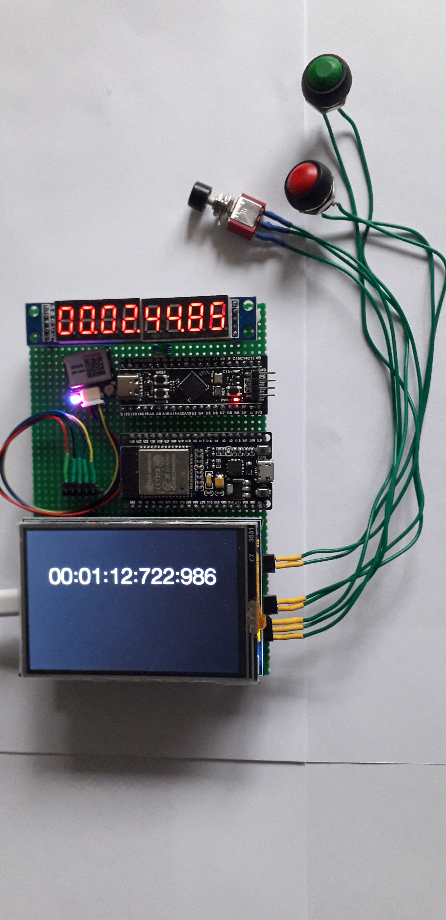
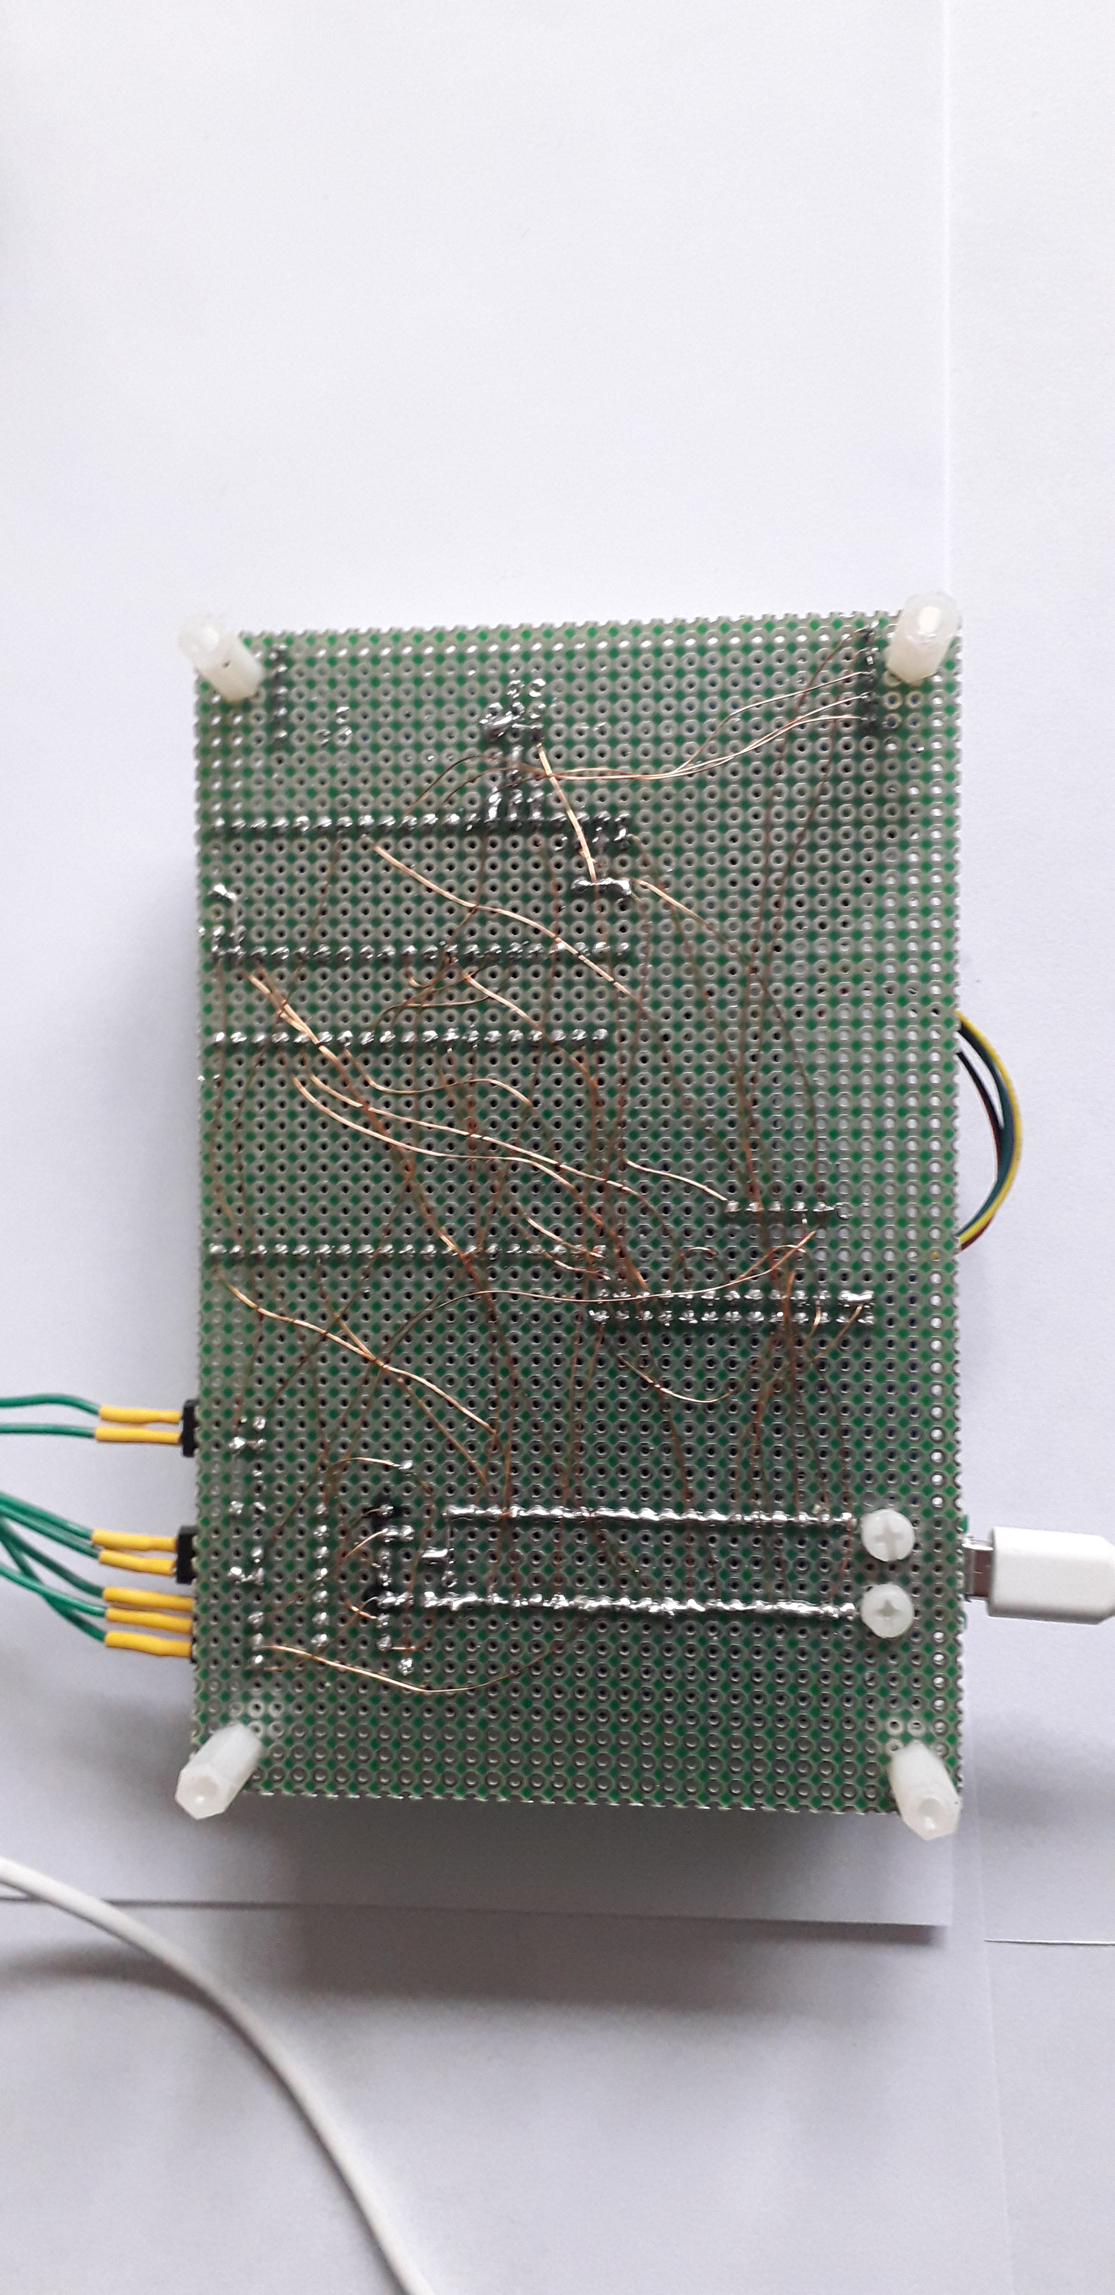
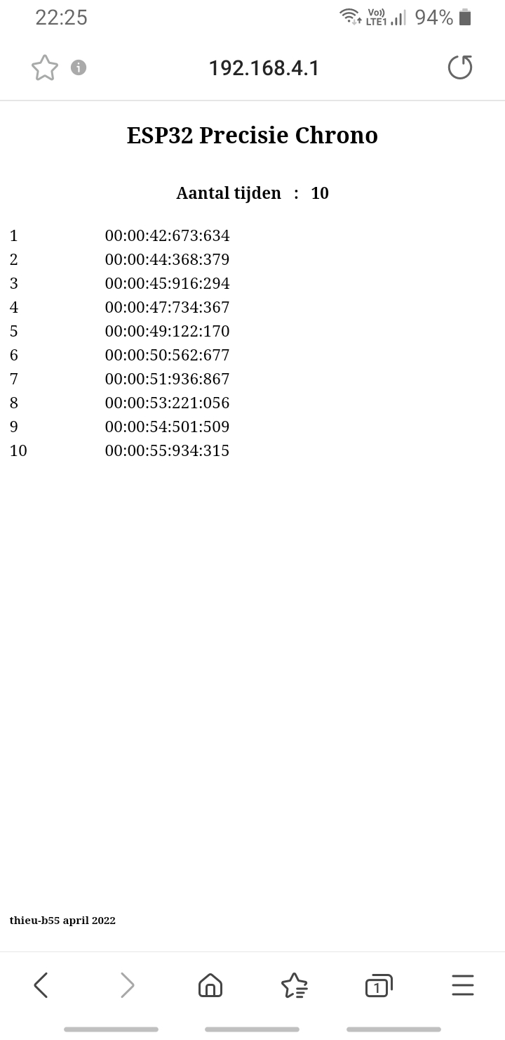

Useful adresses

ESP32 info
https://randomnerdtutorials.com/getting-started-with-esp32/

ESP32 arduino
https://randomnerdtutorials.com/installing-the-esp32-board-in-arduino-ide-windows-instructions/

STM32 TrueStudio software
https://www.st.com/en/development-tools/truestudio.html

STM32 Cubeprogrammer
https://www.st.com/en/development-tools/stm32cubeprog.html

ublox evaluatie software
https://www.u-blox.com/en/product/u-center

ublox NEO-M8
https://www.u-blox.com/en/product/neo-m8-series

Partslist

1 x ESP32-WROOM
https://www.aliexpress.com/item/1005001922031045.html?spm=a2g0o.store_pc_allProduct.8148356.8.3c357ac2VC21vm&pdp_npi=2%40dis%21EUR%21%E2%82%AC%207%2C14%21%E2%82%AC%204%2C43%21%21%21%21%21%40210318b816702302516377833eb65d%2112000020641291381%21sh
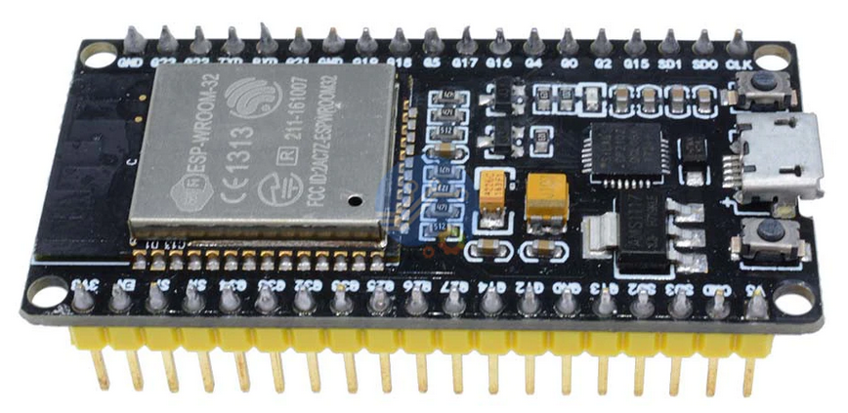

1 x STM32F411 BlackPill
https://www.aliexpress.com/item/1005001456186625.html?gps-id=pcStoreJustForYou&scm=1007.23125.137358.0&scm_id=1007.23125.137358.0&scm-url=1007.23125.137358.0&pvid=f07e86bf-8f17-45f8-8244-1e3d5f8562a3&_t=gps-id:pcStoreJustForYou,scm-url:1007.23125.137358.0,pvid:f07e86bf-8f17-45f8-8244-1e3d5f8562a3,tpp_buckets:668%232846%238109%231935&pdp_ext_f=%7B%22sku_id%22%3A%2212000030707522838%22%2C%22sceneId%22%3A%2213125%22%7D&pdp_npi=2%40dis%21EUR%217.57%216.43%21%21%21%21%21%40210323a416702304644014290e8587%2112000030707522838%21rec&spm=a2g0o.store_pc_home.smartJustForYou_2004270797050.0

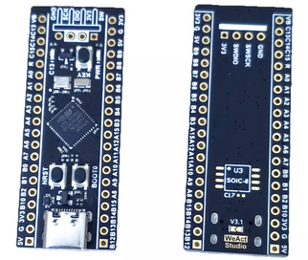

1 x GPS module ublox neo-m8n compatibel i.v.m. tijdsbasis programmatie door STM32F411
https://www.aliexpress.com/item/32852570526.html?spm=a2g0o.store_pc_allProduct.0.0.484f66caKko1RT&pdp_ext_f=%7B%22sku_id%22:%2265326712570%22,%22ship_from%22:%22%22%7D&gps-id=pcStoreJustForYou&scm=1007.23125.137358.0&scm_id=1007.23125.137358.0&scm-url=1007.23125.137358.0&pvid=04b50378-65ca-4e73-84c3-c2a2a246f1de

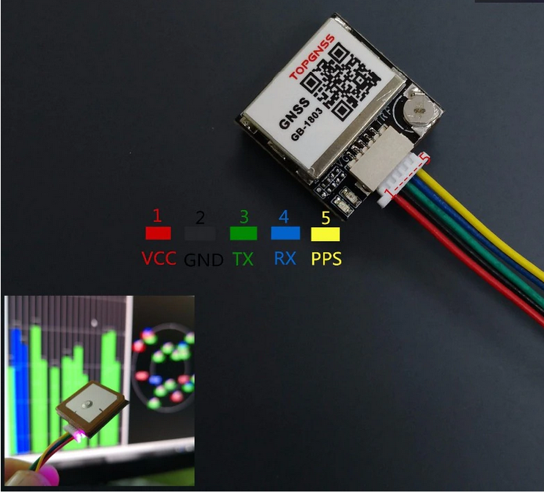

1 x LCD Display
https://www.aliexpress.com/item/32605410449.html?spm=a2g0o.store_pc_allProduct.8148356.1.5a6d67aak1sAxb&pdp_npi=2%40dis%21EUR%21%E2%82%AC%2014%2C44%21%E2%82%AC%2014%2C44%21%21%21%21%21%402100bdec16702303547062129efcf0%2159248080158%21sh

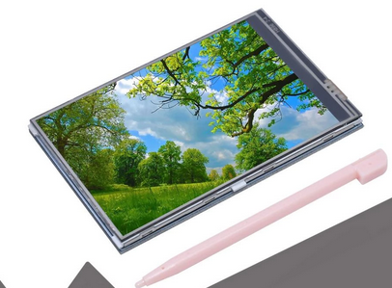

1 x 8 digit LED display
https://www.aliexpress.com/item/32815741807.html?spm=a2g0o.store_pc_allProduct.8148356.6.794315bfkrUnmN&pdp_npi=2%40dis%21EUR%21%E2%82%AC%201%2C28%21%E2%82%AC%201%2C17%21%21%21%21%21%402100bb4a16702308282726855e5738%2110000000865712045%21sh

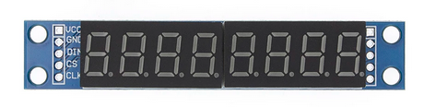

1 x 74HC00

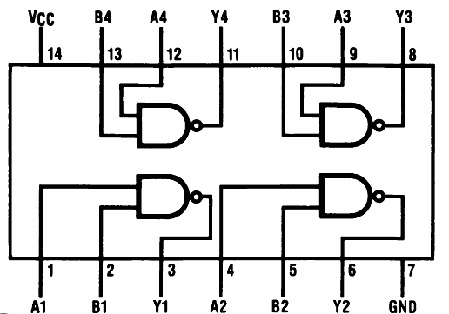

3 x pushbutton N.O.

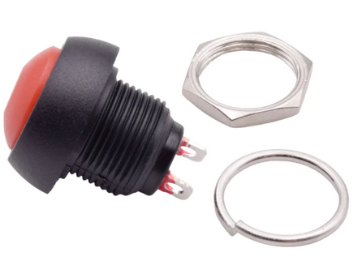

1 x pushbutton changeover contact N.O. C N.C

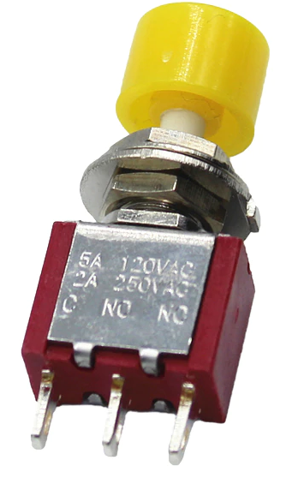

5 x R 4K7

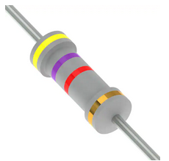

1 x ST-Link V2 for programming the STM32F411
https://www.aliexpress.com/item/1005003575620794.html?spm=a2g0o.productlist.0.0.5e8f763fErfgBt&algo_pvid=346e7784-949e-42b3-b33f-855091b51ce8&algo_exp_id=346e7784-949e-42b3-b33f-855091b51ce8-0&pdp_ext_f=%7B%22sku_id%22%3A%2212000026345111930%22%7D&pdp_npi=2%40dis%21EUR%212.25%211.98%21%21%21%21%21%402103255b16702309932973798e80e2%2112000026345111930%21sea&curPageLogUid=2HyAfOYlho7c

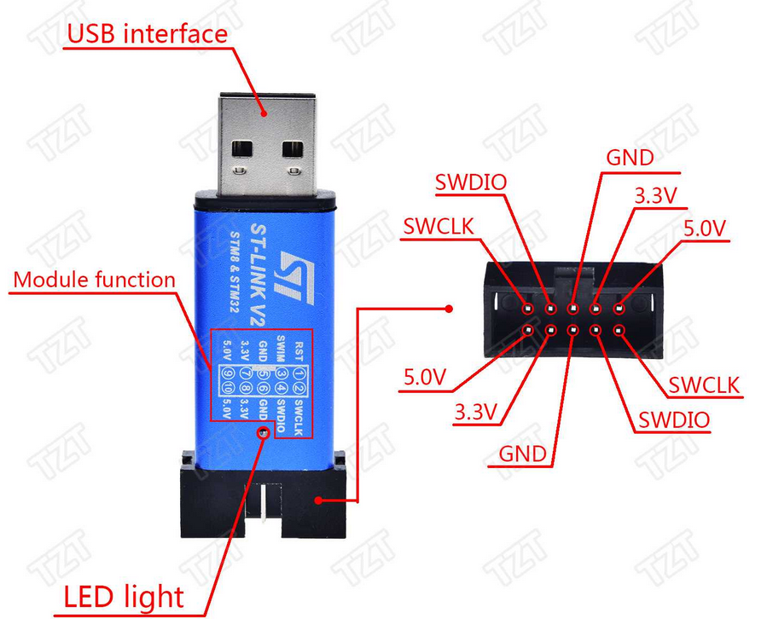

1 x FTDI only necessary if you want to use the U-blox evaluation software
https://www.aliexpress.com/item/32650148276.html?spm=a2g0o.productlist.0.0.32675c85KTDTNv&algo_pvid=5f83f7c0-d2bf-4e84-87ba-9ab743807e95&algo_exp_id=5f83f7c0-d2bf-4e84-87ba-9ab743807e95-1&pdp_ext_f=%7B%22sku_id%22%3A%2210000000738199659%22%7D&pdp_npi=2%40dis%21EUR%211.64%211.44%21%21%21%21%21%402103255a16702310382163471e9816%2110000000738199659%21sea&curPageLogUid=cbnlTkalQgDF

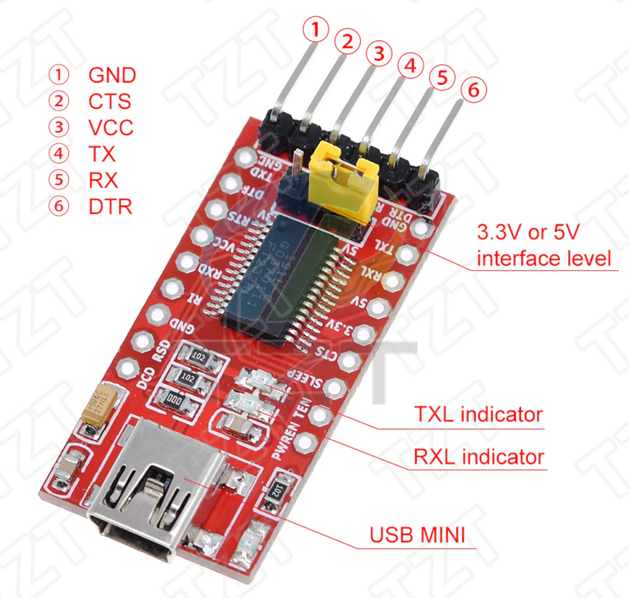

Please note:
GPS module has to be u-blox compatible, the frequency and on/off time of the output pulse is programmed by the STM32F411CEU. Frequency = 1MHz, 100 nSec on, 900nSec off

Connections

Power 5V

+ 5V >> 5V in STM32F411CEU (2x)
>> 5V ESP32-WROOM
>> 5V 8 digit LED display
>> 5V LCD display

GND >> GND STM32F411CEU (2x)
>> GND ESP32-WROOM (3x)
>> GND 8 digit LED Display
>> GND LCD display
>> GND GPS module

/*******/

STM32F411CEU (BlackPill)

USART1 (115200)
PA9 USART1 TX >> ESP32-WROOM RX2 GPIO16
PA10 USART1 RX >> ESP32-WROOM TX2 GPIO17

USART2 (9600)
PA2 USART2 TX >> GPS module RX

SPI 1
PA4 SPI1 /CS >> /CS 8 digit LED display
PA5 SPI1 SCK >> CLK 8 digit LED display
PA7 SPI1 MOSI >> DIN 8 digit LED display

1MHz puls van GPS module in
PA12 >> pulse out from GPS module (parallel PB3) input Timer1
PB3 >> pulse out from GPS module (parallel PA12) trigger used in the program

Start timer
PB0
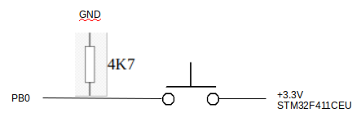

Stop and reset timer
PB2
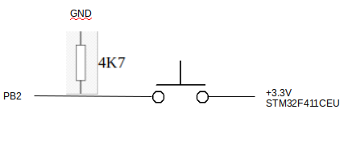

Time registration
PA1

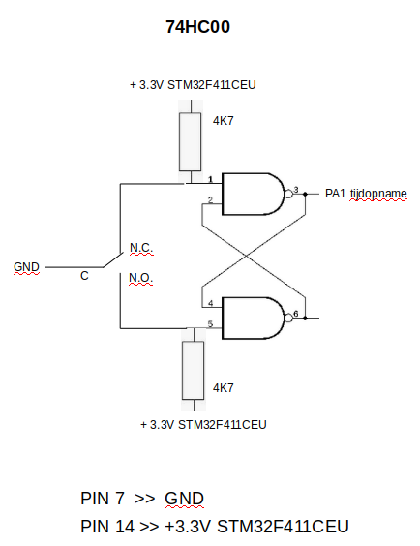

3.3V from STM32F411CEU

>> VCC GPS module
>> 2 x 4K7 74HC00
>> C push-button start timer
>> C push-button stop/reset timer

/*******/

ESP32-WROOM

Serial2
GPIO16 RXD2 << PA9 USART1 TX STM32F411CEU
GPIO17 TXD2 >> PA10 USART1 RX STM32F411CEU

Clear registered times in SPIFFS Flash memory
GPIO27
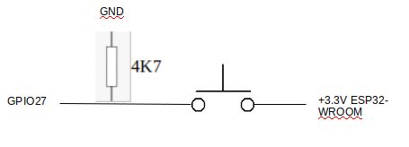

LCD screen
GPIO19 >> LCD_SI/TP_SI LCD screen
GPIO23 >> TP_SO LCD screen
GPIO18 >> LCD_SCK/TP_SCK LCD screen
GPIO15 >> LCD_CS LCD screen
GPIO2 >> LCD-RS LCD screen
GPIO4 >> RST LCD screen

/*******/

GPS module
VCC << +3.3V from STM32F411CEU
GND << GND
RX << PA2 USART2 STM32F411CEU baudrate = 9600
Timing puls >> PA12 STM32F411CEU
>> PB3 STM32F411CEU

/*******/

8 digit LED display
VCC << +5V power supply
GND << GND
IN << PA7 MOSI STM32F411CEU
/CS << PA4 STM32F411CEU
CLK << PA5 SCK STM32F411CEU

/*******/

LCD Display

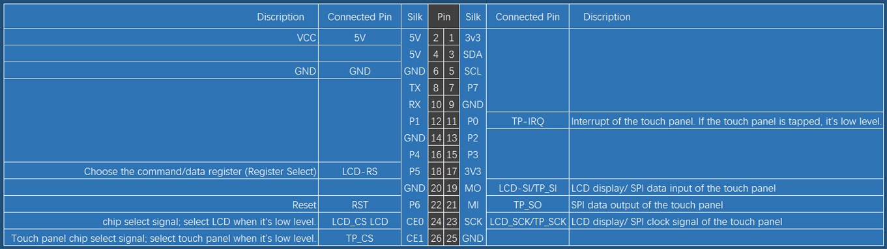
bottom view connector LCD screen

5V << +5V power supply
GND << GND
LCD_SI/TP_SI << GPIO19 ESP32-WROOM
TP_SO << GPIO23 ESP32-WROOM
RST << GPIO4 ESP32-WROOM
LCD_SCK/TP_SCK << GPIO18 ESP32-WROOM
LCD_CS LCD << GPIO15 ESP32-WROOM

/*******/

74HC00
see schematic PA1 STM32F411CEU

Github files

chrono.hex
compiled program for STM32F411CEU can be programmed in STM32F411CEU with ST-Link and STM32Cubeprogrammer .

ST-LINK SWDIO connector STM32F411CEU

GND >> GND
SWDIO >> SWDIO
SWCLK >> SWCLK

when STM32F411CEU has no external power supply
3.3V >> 3.3V

Plug ST-Link in USB computer port
Open STM32Cubeprogrammer
ST-LINK <Connect>
In left vertical bar choose download
Browse and choose chrono.hex
Verify Programming

<Start Programming>

Chrono.zip
after unzip these files can be opened with Atollic TrueSTUDIO
After compiling you find the chrono.hex file in the Debug folder.

chrono_esp32.ino
Can be programmed in the ESP32-WROOM with the Arduino IDE
Before programming find in the Arduino libraries folder the TFT-eSPI folder and change the following files according to these screenprints.

User_Setup.h

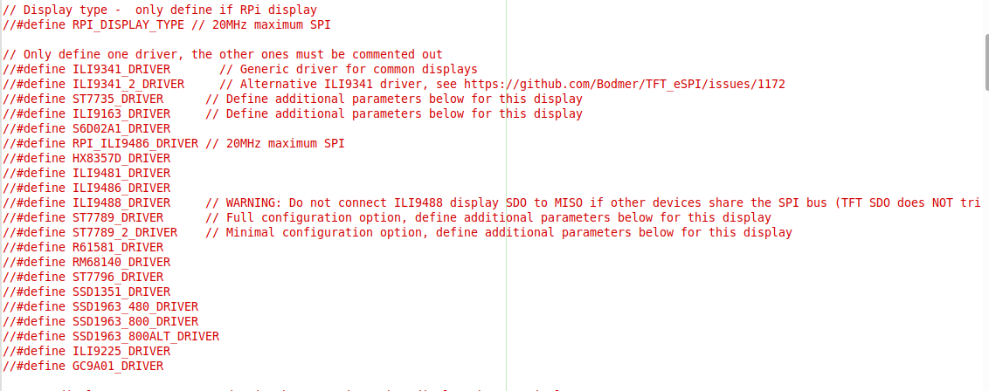
User_Select_Setup.h

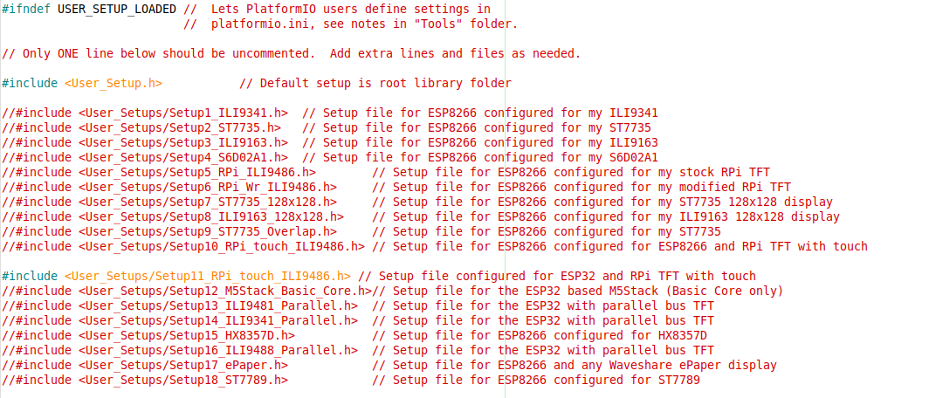
Program the STM32-WROOM.

If all connections are made and the program should be running

How does it work

After start-up the GPS module is prograamed by the STM32F411CEU

8 digit LED display shows 00000000

LCD screen shows a red screen with the text
<Opgeslagen tijden worden gekopieerd naar buffer>
English Stored times are copied to the buffer

After copying the following text is shown
<TIJDEN NIET GEWIST>
English Stored Times are not cleared
Storing new times is not possible

The already stored times are available on the web page.
Connect to
Network : ESP32Chrono
Password : ESP32pswd
Page: 192.168.4.1

Clearing registered times.
Push push-button connected to GPIO27 from ESP32-WROOM at start-up.
LCD screen shows
<SPIFFS wordt geformatteerd>
English SPIFFS is being formatted
After formatting the screen is cleared and the chronometer is ready to use.

Timer is started with push-button connected with PB0 from STM32F411CEU

Timer stop and reset with push-button connected with PB2 from STM32F411CEU

Register a time with push-button connected with PA1 from STM32F411CEU.

The last registered time is shown on the LCD screen.
All registered times with a maximum of 500 a visible on the web-page.
Connect to
Network : ESP32Chrono
Password : ESP32pswd
Page: 192.168.4.1

that’s all, have fun and sorry for my english

groeten,
thieu-b55

